Team T-Shirts 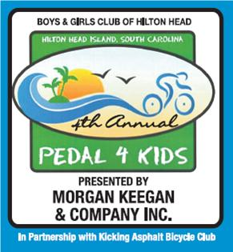

Custom T-shirts are available thanks to the generosity of the Salty Dog T-shirt Factory.

T-shirts are $15 each (for a one color logo) payable to the Salty Dog T-shirt Company. These T-shirts replace the free T-shirts provided with registration.

Your team can select your special team color (each team can have a special color unique to their team), select a logo, team name or message you want on the t-shirt.

Here’s how to arrange for your own Pedal 4 Kids Team T-Shirt!

- Contact the Salty Dog Tee Shirt Factory:

Stuart Booth
Vice President
Salty Dog T-Shirt Factory
67 Arrow Road
Hilton Head Island, SC 29928
843-842-9613
843-842-6355 (fax)
orders@saltydog.com

- Select your T-shirt color, logo and or lettering with Stuart.
- Organize your team and get T-shirt sizes (S, M, L, XL) from your team members.
- Collect the money from team members at $15 a T-shirt.
- Finalize your order with Stuart by September 20th (money, sizes, color, logo and/or lettering).
- Pick up T-shirts from the Salty Dog and distribute them to your team.
- Have fun, a good experience, and helps kids with your team at the Pedal 4 Kids bike ride September 25, 2010.

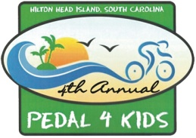
BOYS & GIRLS CLUB OF HILTON HEAD
PEDAL 4 KIDS TEAM T-SHIRT FORM

Please turn in this FORM to the Salty Dog for your Team Shirts!

Name | T-Shirt Size
1
2
3
4
5
6
7
8
9
10
11
12
13
14
15
16
17
18
19
20
21
22
23
24
Team Name: _________________________

Team Captain: _______________________

